We do not know the current architecture.
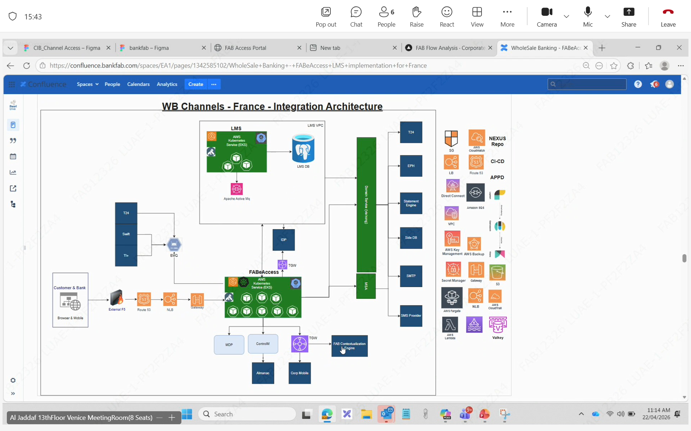
Postgess DB

